Chemistry Test Revision

* Properties of metals and non-metals
* Which elements are metals and non-metals
* Rules for naming elements and their symbols e.g. Capital, then lowercase letter
* Groups and periods on the periodic table
* Define molecular element
* Define a compound
* Naming ionic compounds
* Naming covalent compounds
* Reading chemical formula’s for compounds   
  e.g How many different elements are in NaNO3? How many atoms?
* What is a chemical change?
* What is a physical change?
* Identifying examples of changes as physical or chemical
* Properties of physical and chemical changes (how you can you tell?)

e.g. explosion, light is produced, colour change etc.

* Writing word equations for chemical reactions and identifying reactants and products

The test will have 8 short answer questions and 10 multiple choice. You will be given a periodic table to use during the test ☺

Writing word equations for chemical reactions

Write word equations for each of these reactions:

* + When fluorine gas comes into contact with calcium metal, calcium fluoride is produced.

* + After mixing sodium hydroxide with sulfuric acid, sodium sulfate and water are formed.

* + Iron metal and sodium chloride are produced when sodium metal reacts with iron chloride.

* + In a car engine, petrol reacts with oxygen and burns. This reaction produces carbon dioxide and water.

* + Calcium oxide and carbon dioxide are produced when heating calcium carbonate causes it to decompose.

* + Many buses in WA use hydrogen fuel cells as a source of energy. In this type of fuel cell, hydrogen and oxygen react together to provide energy to the bus. As a result of this reaction, water is produced.

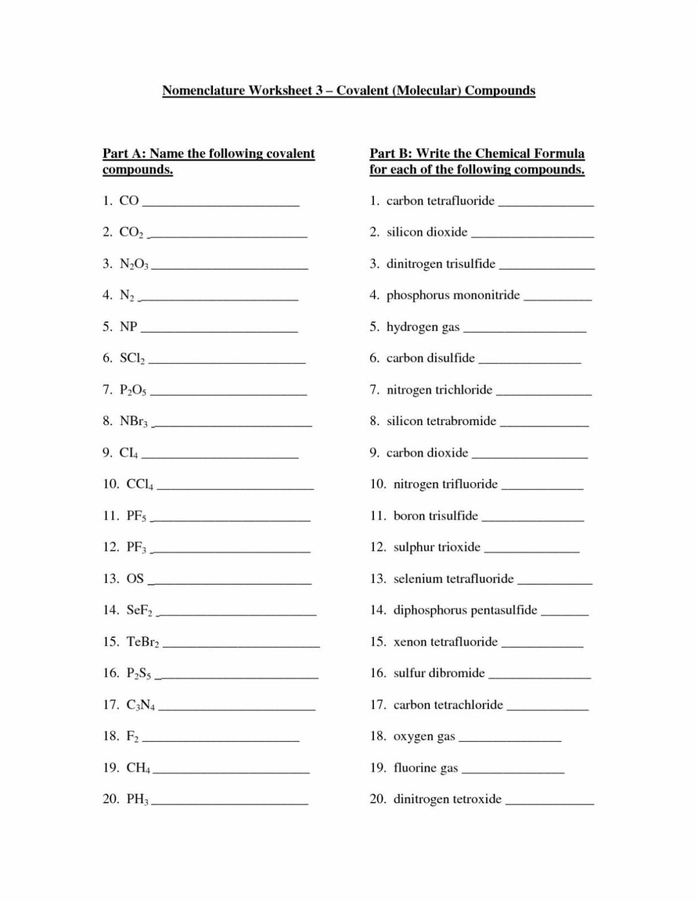

Name the following ionic compounds

1. MgBr2 ____________________________________
2. KCl ______________________________________
3. FeCl2 _____________________________________
4. FeCl3 _____________________________________
5. CrF2 ______________________________________
6. Al2S ______________________________________
7. PbO ______________________________________
8. Co3N2 _____________________________________
9. Mg3N2 _____________________________________
10. BaO ______________________________________

Fill in the missing information in this table:

|  |  |  |  |
| --- | --- | --- | --- |
| **Formula of substance** | **Number of atoms of each element** | **Scientific name of substance** | **Molecular Element or Compound** |
| CF4 | Carbon × 1  Fluorine × 4 | Carbon tetrafluoride | Compound |
| N2 |  |  |  |
| CO2 |  |  |  |
| O2 |  |  |  |
| MgF2 |  |  |  |
| Na2SO4 |  | Sodium Sulfate |  |

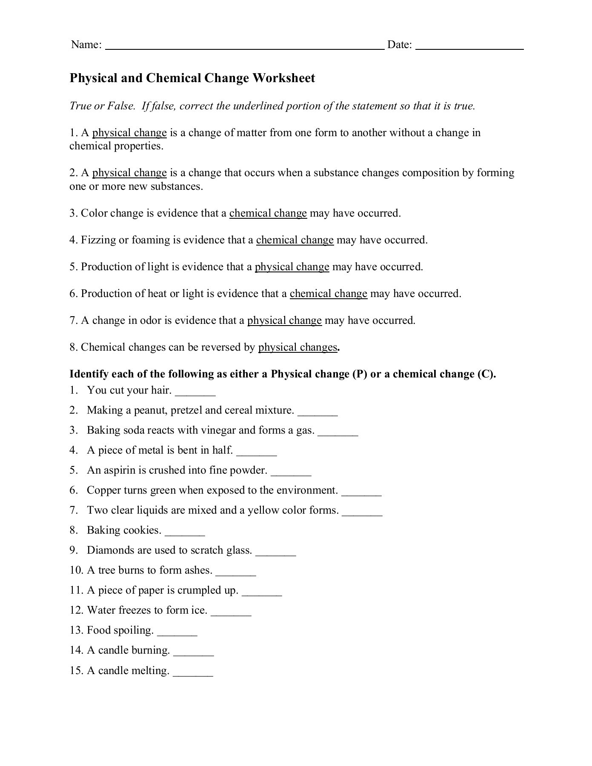

Elements Compounds and Mixtures

1. Decide whether each of the following is an element (E), molecular element (ME) or compound (C).

O2 CO2 H2 HF Fe H2S C60 C6H12O6 CO Co

____. ____. ____. ____. ____. ____. ____. ____. ____. ____.

1. Look at the diagrams below and decide whether each one represents the particles in an element, molecular element, compounds or mixture.

1. Write the formula for each of the following molecules in the diagrams below.

1. Draw the molecules represented by the following formulae.

|  |  |  |  |  |
| --- | --- | --- | --- | --- |
| HCl | Fe | H2S | NO2 | NaCl |

**Use the word bank below to complete the following passage.   
Some words may be used more than once.**

|  |  |  |  |
| --- | --- | --- | --- |
| **metalloid** | **bend** | **dull** | **properties** |
| **electricity** | **liquid** | **Atomic number** | **brittle** |
| **gases** | **metals** | **Non-metals** | **solids** |
| **conduct** | **temperature** | **shiny** | **staircase** |

Elements are arranged on the periodic table according to their ___________________.

Every element is either a metal, a non-metal or a _________________.

____________________ are located on the left side of the periodic table.   
Some common ________________ that metals have are:

* They are ________________ – metals have a smooth, shiny surface
* They are good ___________________ – electricity is able to travel through metals
* They are malleable – metals can ____________ without breaking
* They are __________________at room temperature – *except for mercury (Hg)*

_____________________are located on the right side of the periodic table.

Common properties that non-metals have are:

* They are _______________ – non-metals usually have a rough, non-shiny surface
* They do not conduct _______________ – electricity is unable to travel through non-metals (*except graphite)*
* They are _____________ – solid non-metals will break if they are bent
* They may be __________ liquids, or __________ at room _________________.

Metalloidsare located in a _______________________ shape between the metals and non-metals. Metalloids share properties with metals **and** non-metals.

